VAJA 10 - 6. razred
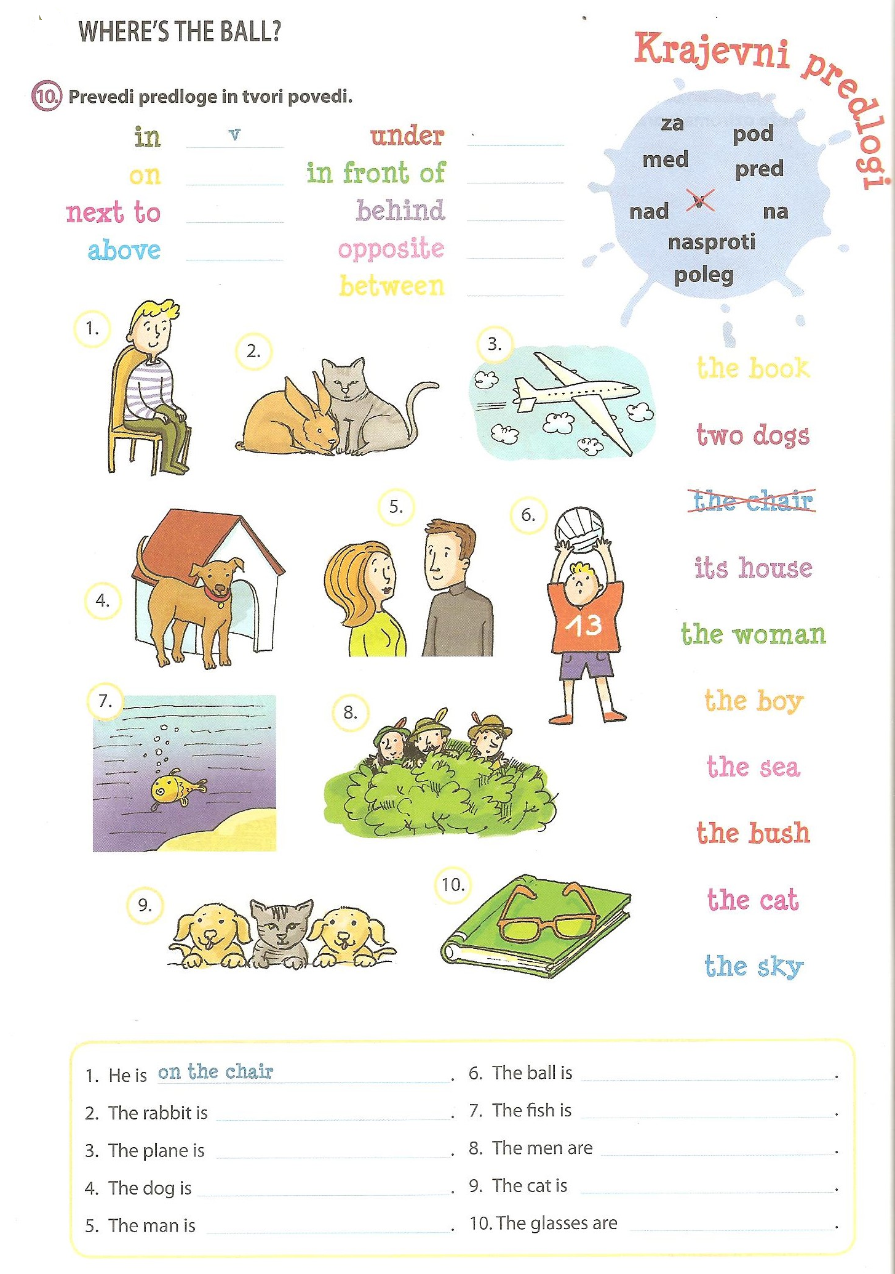

REŠITVE:
The rabbit is next to the cat.
The plane is in the sky.
The dog is in front of its house.
The man is opposite the woman.
The ball is above the boy.
The fish is in the sea.
The men are behind the bush.
The cat is between the dogs.
The glasses are on the book.

