8. razred, ANGLEŠČINA
Pouk na daljavo, 24. marec 2020, 4. ura
Distance learning during temporary school closure
ZAPOREDNA ŠT. URE pouka na daljavo: 4 | DATUM: 24. 3. 2020 | RAZRED: 8.
NASLOV URE: Present perfect - izkušnje
Hello. Get most out of this online lesson, so let’s start ...
STUDENT'S BOOK, p. 56: V besedilu Ambitions poišči slovnične strukture – present perfect in jih zapiši v zvezek:
Primer: Tilda: I've been in some plays at the theatre.
HAVE BEEN = 'VE BEEN
HAS DONE= 'S DONE
Present perfect uporabljamo, ko govorimo o izkušnjah (experiences) v življenju, ne da bi povedali, kdaj se je (ali ni) kaj zgodilo.
Rešitev vaje, UČ 56, Present perfect structures in the text Ambitions: I haven't been on TV / I've seen all her films/She hasn't done / Since then she's been /She's also done/ She's given some
WORKBOOK, p. 44
SEND TO TEACHER!
School closure caused by coronavirus

- Describe one day during school closure (from morning till night) in the past
- Write 3 reasons why this situation is good and 3 reasons why it is bad for you.

Write about 150 words. I hope you will be able to write this in seven days and send it to my e-mail.
Kako preživljaš dneve v času, ko ne moreš v šolo? Izberi en dan in opiši, kako si ga preživel od jutra do večera. V drugem in tretjem odstavku pa opiši tri razloge, kaj ti je ta čas prinesel dobrega in kaj slabega. Besedilo lahko natipkaš, napišeš v zvezek in skeniraš ali slikaš s telefonom in pošlješ na moj e-naslov.

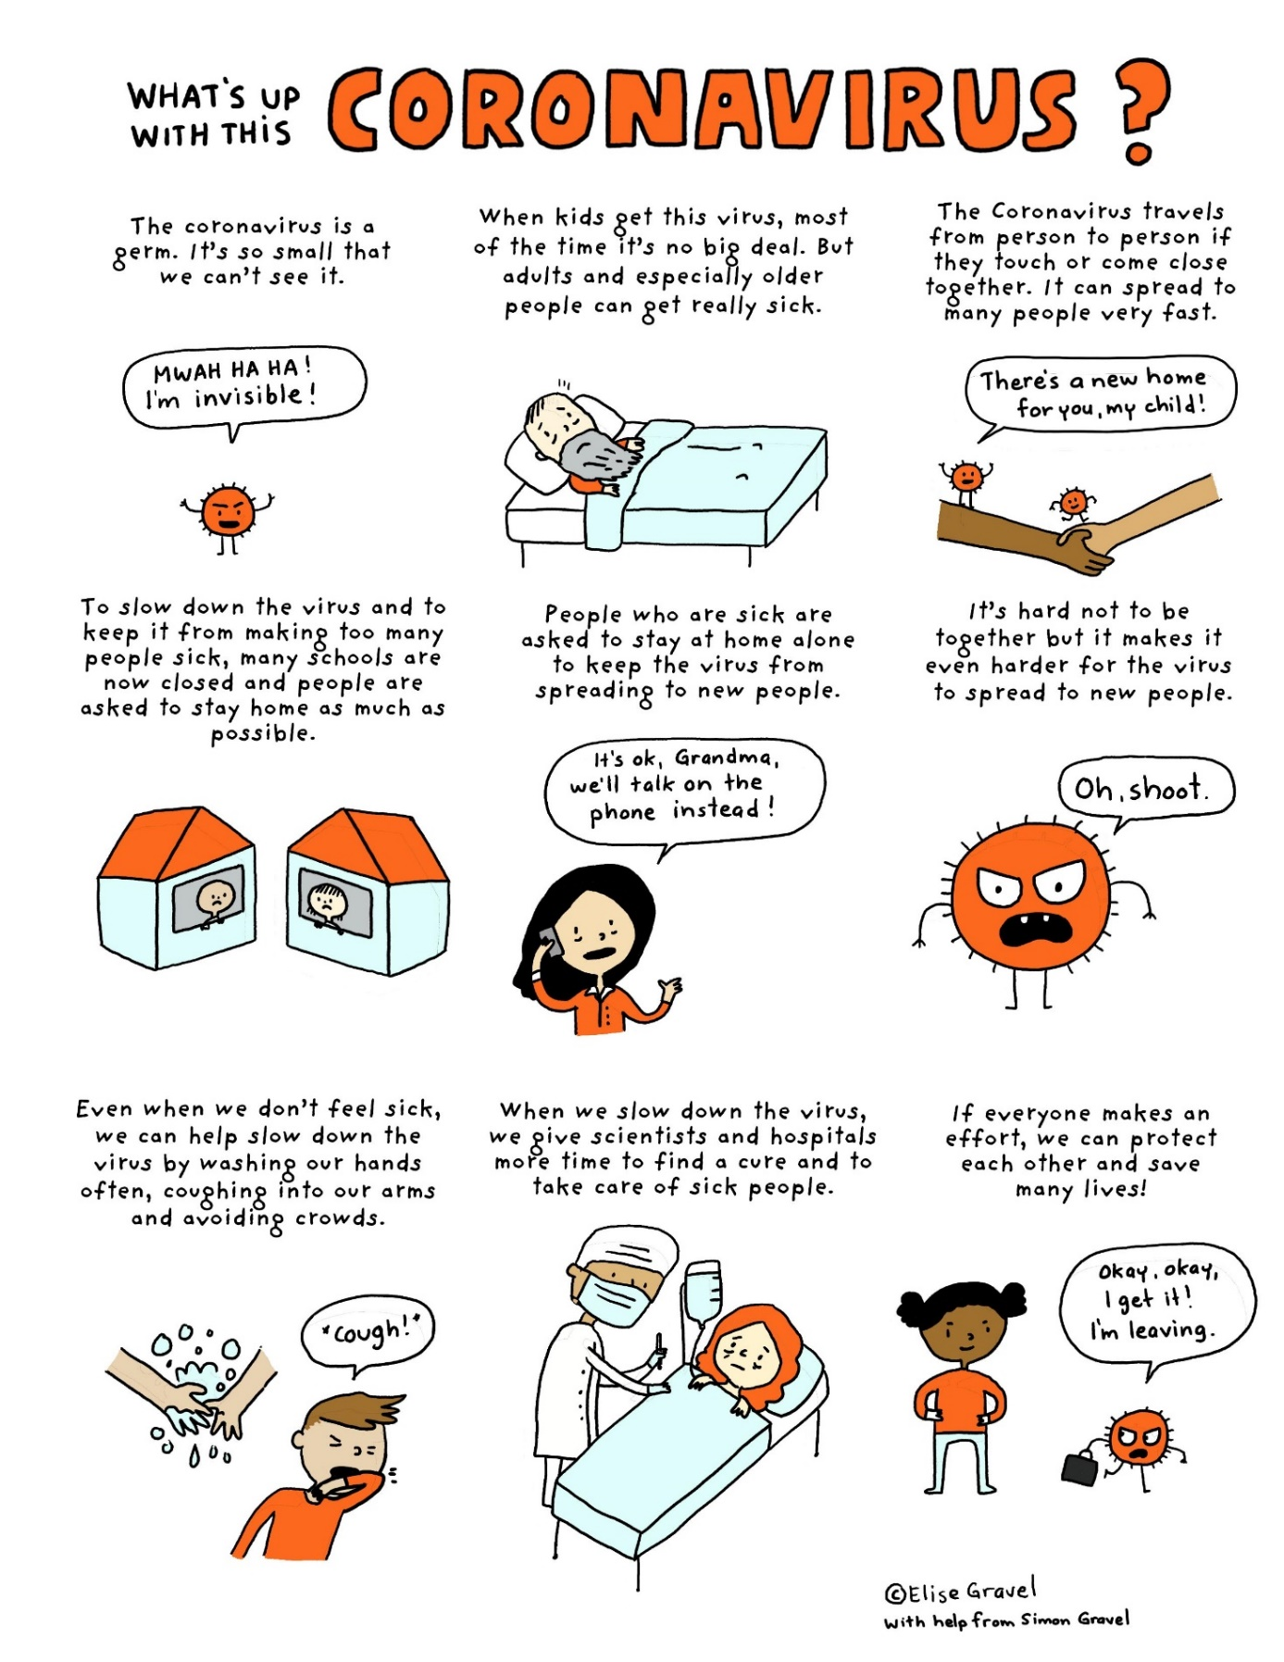
Source: http://elisegravel.com/en/blog/coronavirus-free-printable-comic-for-kids/?fbclid=IwAR0t-ng31nUXobbkhLEkgxwrs_9VCsR50lyeYZIWF_AxzSJkqPO14vlwoTQ

