6. razred, ANGLEŠČINA
Pouk na daljavo, 1. april 2020, 11. ura
Distance learning during temporary school closure

NASLOV URE: I can paint (vaja slušnega razumevanja)
ZAPOREDNA ŠT. URE pouka na daljavo: 11. | DATUM: 1. 4. 2020 | RAZRED: 6.
Hello, everyone.
Danes poslušaj posnetek, ki je na spodnji povezavi in reši 1. vajo.
Posnetek (British Council): I can paint:
https://learnenglishkids.britishcouncil.org/grammar-chants/i-can-paint
1.Prepiši vajo v zvezek. Poslušaj posnetek in izberi pravilno besedo, ki jo slišiš na posnetku.
https://learnenglishkids.britishcouncil.org/grammar-chants/i-can-paint

a.I can_________________ and I can draw. colour/ paint/ play
b.I can dance and I can________________ . cook/ act/ sing
c.I can ________________a little English. write/ speak/ shout
d.But my________________ can't do these things. cat/ dog/ brother
e. He can ________________and he can eat. sleep/ drink/ talk
f. He can________________ every night. dance/ go out/ watch TV
g. But he can't do my________________ . washing/ hair/ homework
2. Prepiši vajo v zvezek in vstavi CAN Ali CAN’T. Ali znajo, zmorejo?
a.Dogs_____________ jump.
b.Dolphins_____________ talk to each other.
c.Penguins_____________ fly.
d.Tortoises _____________run very fast.
e.Cheetahs_____________ run very fast.
f.Owls _____________see very well at night.
g.People _____________see very well at night.
h.Babies _____________walk.
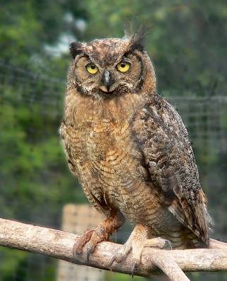 an owl 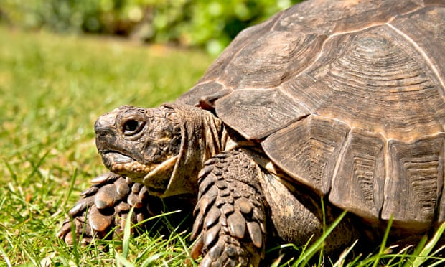 a tortoise
https://okc-audubon.org/great-horned-owl/ Photograph: Susan Guest/Getty Images/iStockphoto
REŠITVE, 1. vaja:
a)paint b) sing c) speak d) cat e) sleep f) go out g) homework

REŠITVE, 2. vaja:
a) CAN b) CAN c) CAN’T d) CAN’T e) CAN f) CAN g) CAN’T h) CAN’T

