5. razred, ANGLEŠČINA, OŠ Col
POUK NA DALJAVO, 26. marec 2020, torek
Distance learning during temporary school closure

NASLOV URE: Emily and Sarah (odgovori na vprašanja)
ZAPOREDNA ŠT. URE pouka na daljavo: 6. | DATUM: 26. 3. 2020 | RAZRED: 5.
Hello again! Check your answers about Jessica’s dad.
8 odgovorov na vprašanja iz torkove naloge, PREVERI, če imaš pravilne odgovore:
1 Steve is Jessica’s dad. 2. He has eggs and sausages. 3. He’s a firefighter. 4. He goes to work by car. 5 Jessica’s dad checks the firefighting equipment. / He checks his mask and torch. 6. Yes, they are. 7. Because he talks to children about fire safety. 8. Yes.
UČBENIK, str. 67: Preberi besedilo in nato reši 2. in 3. nalogo v zvezek.
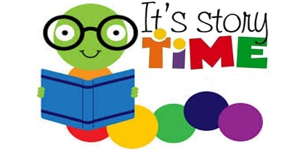
The Kissing Hand je naslov pravljice,
ki jo lahko poslušaš, če klikneš na ta spletni naslov: https://www.storylineonline.net/books/kissing-hand/

From the story:
"Whenever you feel lonely and need a little loving from home, just press your hand to your chest and think, 'Mommy loves you.'"

