5. razred, ANGLEŠČINA
Pouk na daljavo, 5. teden, 16. april 2020, 14. ura, torek
Distance learning during temporary school closure

NASLOV URE: South Africa (besedilo v učbeniku)

ZAPOREDNA ŠT. URE pouka na daljavo: 14 | DATUM: 16. 4. 2020 | RAZRED: 5.
Let's go to South Africa today!
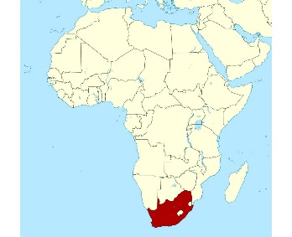South Africa
- REŠITVE torkovega učnega lista:
Sally gets up at 7 o'clock. She goes to bed at quarter past nine.
Gary has breakfast at quarter past seven. He has lunch at quarter to one.
Rod goes to school at quarter to nine. He goes home at half past three.

- Učbenik, str. 66: South Africa
SOUTH – jug, NORTH – sever, EAST- vzhod, WEST – zahod
Preberi besedilo. Pri razumevanju si pomagaj z razlago besed. Zapiši jih v zvezek.
Vocabulary
a guide –vodnik (po parku)
take tourists around the park –voditi turiste po parku
look for animals –iskati živali
difficult –težko
find –najti
binoculars –daljnogled
animal tracks –živalske sledi
on the ground –na tleh
camouflaged –prikrit, skrit, maskiran

Read the sentence and decide whether it is TRUE (T) or FALSE. (F).
- Preberi spodnje povedi in napiši črko T, če so resnične ali F, če so napačne.

a) Nombeko’s dad doesn’t like his job. ____
b) There are lots of crocodiles and gorillas in the park. ____
c) The animals in the park wake up in the afternoon. ____
d) Nombeko’s dad looks for animal tracks. ___
e) Nombeko is from South Africa. ____
f) The park isn’t very big. ___
g) The animals are difficult to find. _____
h) Tourists come to the park to see the animals. ___

